**Custom Models**

**Latest Submission Grade 100%**

**1.**

Question 1

Following is an example of a deep and wide network structure.

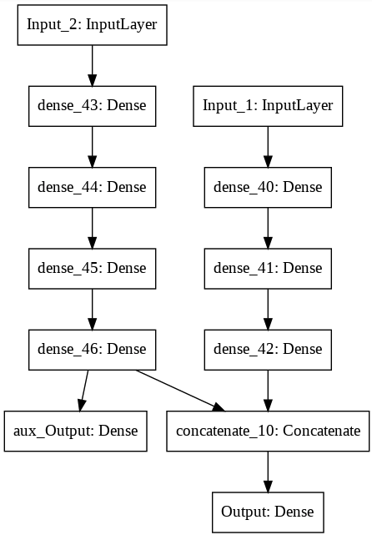

**1 / 1 point**



False



True

**Correct**

Correct! This model structure does not have an input path that go through a shallow, or a wide layer.

**2.**

Question 2

Consider the following code and check all that are true:

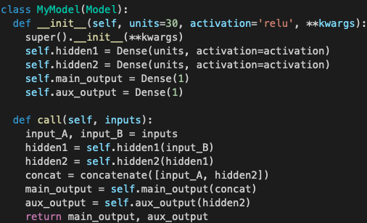

**1 / 1 point**



The *init* function initializes the *MyModel* Class objects, as well as the attributes that are inherited from the *Model* Class.

**Correct**

Correct!



The output layers cannot give more than 1 result each.

**Correct**

Correct! They each hold only 1 unit.



The code is incomplete in the sense that you can only initialize and construct your model, you cannot perform training or inference.



The *concat* should be defined within the *init* function instead of the *call* function as it is also a hidden layer.

**3.**

Question 3

You have learned that Sequential and Functional APIs have their limitations.

How can you build dynamic networks where the architecture changes on the fly, or networks where recursion is used? Check all that are true:

**1 / 1 point**



Using Sequential API



Using Functional API

**Correct**

Correct! With Functional APIs it is possible to build these networks, but it would require a lot of coding.



Using model subclassing

**Correct**

Correct! With model subclassing it is relatively easier to build these complex networks.

**4.**

Question 4

Which one of the following is a false statement regarding model subclassing?

**1 / 1 point**



You can have modular architectures



You can make use of Functional and Sequential APIs when writing code for model subclassing.



Instead of tweaking the entire architecture, you can have different modules and make changes in them as required, as opposed to entirely rewriting the structure.



You cannot introduce a branch structure in the architecture when doing model subclassing.

**Correct**

Correct! You can have branches within your network

**5.**

Question 5

Consider the following two images:

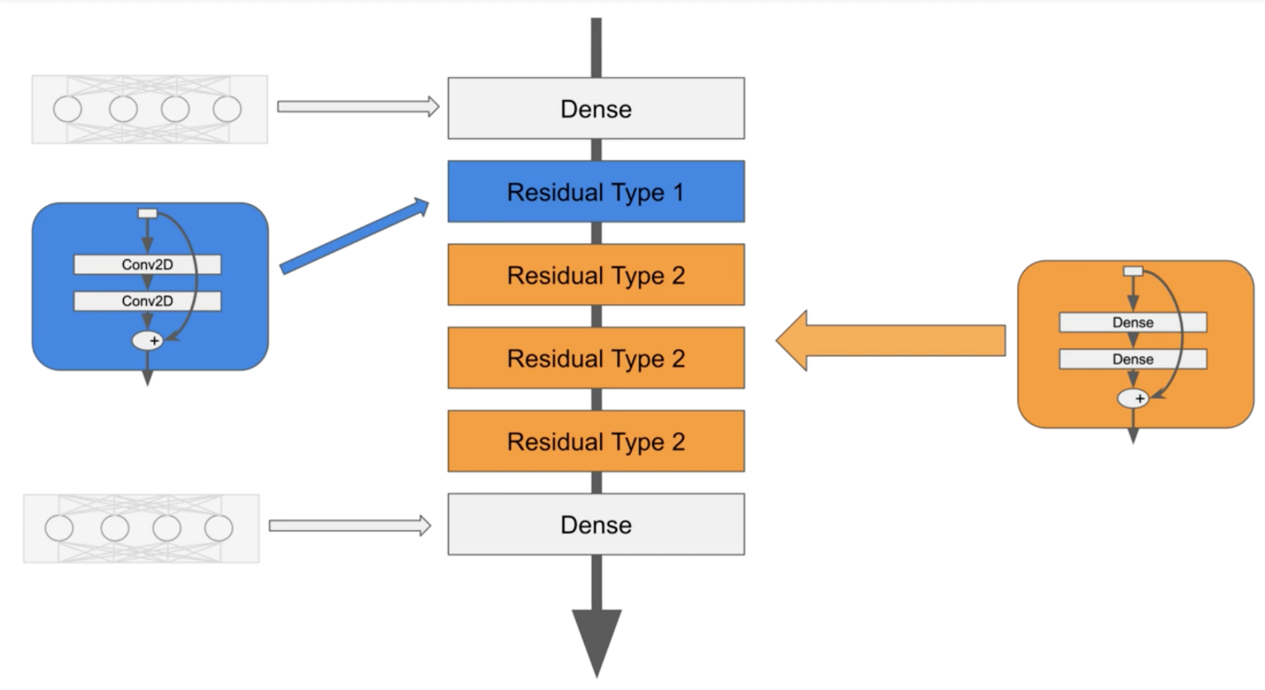

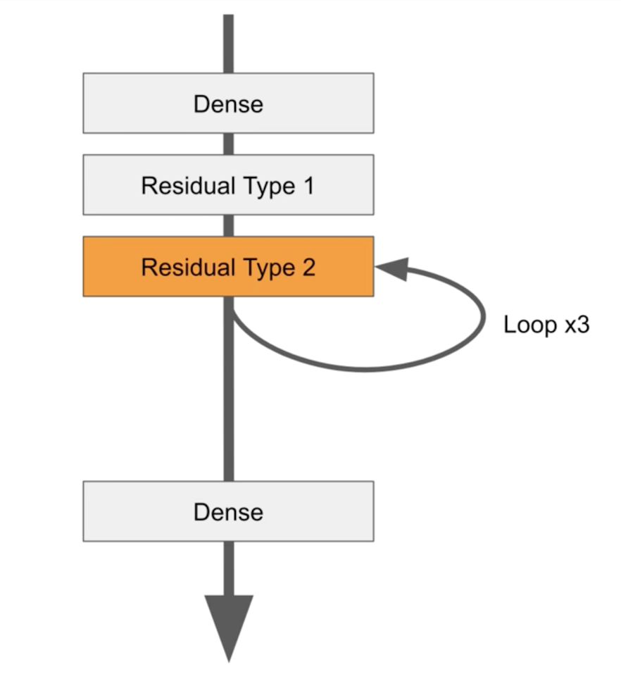

Check all that are true:

**1 / 1 point**



You make a loop of *Residual Type 2* blocks because you want to reduce the depth of the network (making it less complex of an architecture)

**Correct**

Correct!



Each Residual block has two hidden layers and one add layer in it.

**Correct**

Correct!



You loop *Residual Type 2* (*Dense* layers) because you cannot make a loop of *Conv2D* layers (*Residual Type 1)*



When you make a loop of *Residual Type 2* blocks, each block could have the same weights.

**Correct**

Correct!